Chroma

Subject: chemistry  Related Subjects: | Grade Level(s): 9-12  Length of Lesson: | Type: Inquiry / Design / Project  Keywords: Chromatography

Lesson Overview
Use this section to describe at a high level what the lesson is. Should be no more than 3-4 lines.

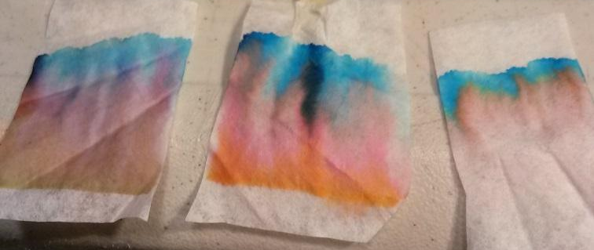
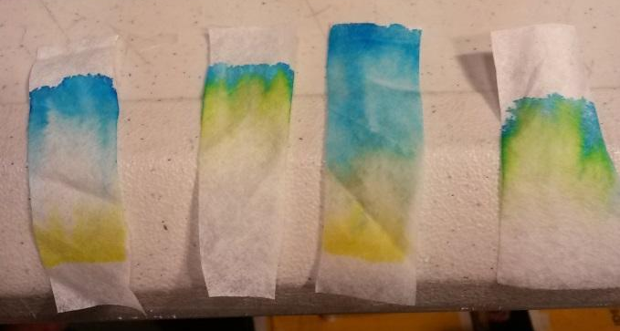

Chromatography results from black color markers
Chromatography results from green color markers

Lesson Focus
What is the central question or phenomenon being investigated? What problem are they trying to solve?

Lesson Objective(s) | This project will introduce the students to a common analytical chemistry technique. At the end of the project students will:  - Be more curious about how to identify and separate substances  - Learn about chromatography. Vocabulary: Mobile phase, Stationary phase, Analyte, Pigment, Polarity  - Learn about physical properties of chemicals

Lesson Timing

5 minutes | Introduce the Lesson
30 minutes | ...

Materials | - Cups  - Coffee Filter  - Binder Clips or Tape  - Thin wood dowels or balsawood or skewers  - Markers (different brands of the same color)  - Water
Instructor Prep | - Step 1
Related Resources | - List related lessons/ppts etc available from USC or outside, trusted orgs

Lesson Plan

Introduction
Chromatography is a widely used technique in chemistry for identifying liquids or gases. It works by separating the compounds in the mixture based on their chemical properties. In paper chromatography, the analyte is carried up the stationary phase by capillary action of the mobile phase (usually water). In this project, the students solve a mystery by matching the chromatography results of markers to identify the criminal that left the note.

Procedure
Taken from Lessa’s Chromatography Lesson:
*Changes may include using a green marker scenario as well (depending on number of students)

The mystery: The mystery scenario for this lesson will be a theft at the Los Angeles Natural History Museum. Make it clear that this mystery is pretend. Tell the students that you need their help, because one of the dinosaur skeletons at the museum was stolen! Left at the museum was the following ransom note:

HAHAHA, I’m so smart you’ll never catch me! If you want your dinosaur back, give me free coffee for life!
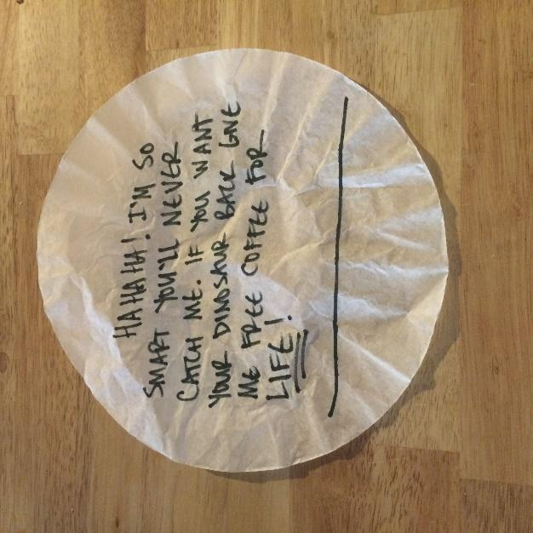

The note was written on a coffee filter in black marker. Clearly the thief drinks a lot of caffeine! There were four people seen in the museum just before the dinosaur went missing, and each had a black pen in their possession. Below are statements the investigators took from each suspect, and more insight about each suspect.

- Cara Lott: I am a mother of three. I work for a group that helps dying children get their last wish. I would never steal a penny
Investigator: Cara seems like a kind and giving person, but maybe she’s kind enough to steal a dinosaur! It is rumored that one of the dying children she works with wished to have a dinosaur of his own. Maybe she stole to dinosaur to fulfill his dying wish?

- Trudy Lenz: You may have seen some of my work on TV. I make music videos. I went to the museum to see the exhibits and eat at the café
Investigator: We’ve discovered that Trudy’s last music video was called “Rock the Dinosaur.” Perhaps Trudy stole the dinosaur skeleton to feature in one of her videos? And she was at the café, perhaps she’s a coffee lover, like our theif.

- Professor Terry Daktil: I work across the street from the museum, at USC. I teach my students about dinosaurs and took them to see the exhibit. I would never be foolish enough to steal a dinosaur!
Investigator: Professor Terry Daktil is working on his own dinosaur exhibit for his lab at USC. Could he be stealing from the museums exhibit to build his own? And might he need lots of coffee to get through all the work he has to do as a professor?

- Vera Klooless: What dinosaur? I didn’t even know there were dinosaurs at the museum. I don’t like science. I only went to the museum because my brother made me.
Investigator: Vera may know more than she is letting on. When we found her in the museum, she had a high level book about dinosaur fossils in her backpack.
Part 1: Chromatography set up
The goal of the first part of this activity is to introduce students to the procedure they will use to investigate evidence using chromatography
- Provide each student with a coffee filter, a coffee stir stick, a piece of tape, and a cup of water.
- Have students cut the coffee filter into strips approximately 1 inch by 4 inches
- Have students tape one strip of coffee filter to a coffee stir stick, then set the stir stick over a cup of water so that the filter strip hangs down, just touching the water
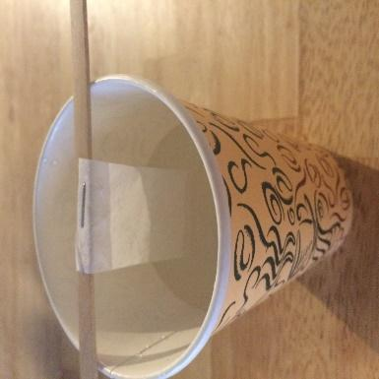
- Ask students to observe what happens to the coffee filter, and describe what they see (water should travel up the filter)
Part 2: Testing the ransom note
- Read the ransom note out loud.
- Cut 5 strips of test paper from the ransom note, as shown by dashed red lines
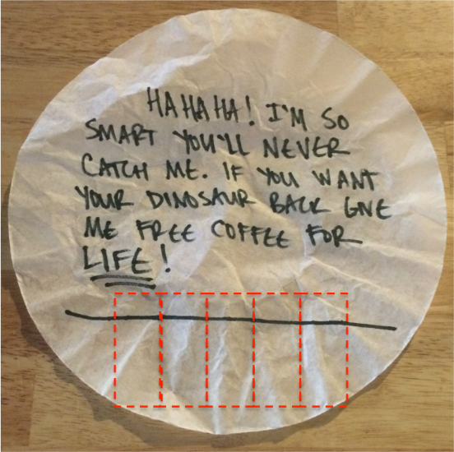
- Ask students to predict what will happen when water travels up the paper through the ink marks
- Let students know that the ransom note is the only piece of evidence they have to solve the crime. To make sure they don’t destroy the evidence, emphasize that when they set up their test, the water should just touch the bottom of the test strip, and not come in contact with the ink. Take one strip and show them a demonstration of how the test should be set up
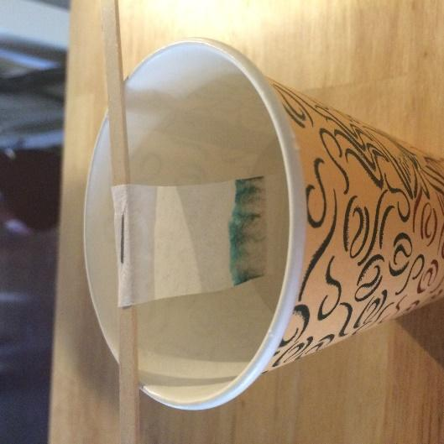
- Divide students into 4 groups (one group per table) and let each group test one strip from the ransom note. When the water has moved ¾ of the way up the test strip, remove it from the water and tape it to a piece of plain paper to dry. Label the paper with the heading “ransom note”
Explain to students that the colors they see on their piece of the ransom note are the pigments that were mixed together to make black ink. A pigment is a chemical that makes something look a certain color. Every company that makes pens uses a different combination of pigments. What the students have done by testing the ink on the filter paper is separate out each pigment in the mixture. They have created a color pattern called a chromatogram.
- Have students look at each others chromatograms. Ask if they are the same, or different. Explain that the general pattern is the same, but there may be slight variations. Variability is something all scientist deal with – results can be slightly different from test to test.
- Ask students why they think the pigment colors separate on a chromatrogram.
Explain that the pigments in ink are made up of molecules. Some molecules are bigger/heavier/more attracted to water than others. Molecules also have lots of different shapes. For these reasons some molecules move up the paper more than others, creating separation.

Part 3: Testing the suspect pens
- Introduce the suspects in the case by asking student volunteers to read the suspect statements. Follow each statement by revealing the additional details about each suspect provided by the investigators.
- Tell students that the number assigned to each suspect is also assigned to the pen that suspect had on them when they were found at the museum.
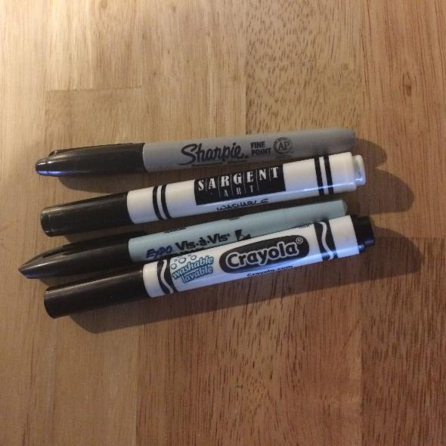
- Have students brainstorm how they could use chromatography to test the suspect’s pens and determine who wrote the note.
- Have the students prepare chromatography test strips from each pen. To keep track of which test strip goes to which pen, have them number the top of their test strips in pencil. When the test is completed, they can add each strip to their piece of paper, and label each strip on the paper.
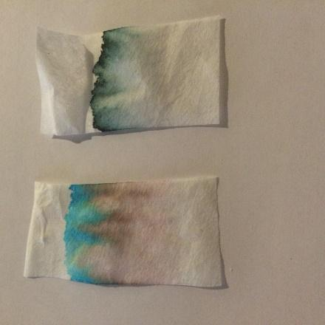
- Ask the students what they observe in their chromatograms. Specifically for sharpie, have them observe what happens and ask them why they think sharpies are called “permanent” markers (the line will not move on the strip marked with sharpie)
- Once all four strips have been tested, have students compare the ransom note chromatogram to the suspect pens to try to determine who wrote the note
- Ask each group which suspect they think stole the dinosaur. Have them look at each others chromatograms again and see if all the tests show the same result.
- Finally, ask the students if the evidence of the pen test is enough to prove that the suspect is guilty. Let them know that one possibility is that the suspect used their pen to write the note, but this is not the only possibility. Ask them to think like detectives and come up with other possibilities (the criminal knows what type of pen the suspect uses and used the same pen type to frame them, the criminal planted the pen in the suspects bag, etc.). Point out that in the real world, and in scientific investigations as well as criminal ones, lots of evidence is required to draw any conclusions.

Wrap-up
End the lesson with some final discussions about what students designed/discovered. Connect their activity back to the focus question/problem, real world examples, and STEM careers.

Also include notes about any special cleanup considerations

Lesson Background for Teachers

Suggested Real-World STEM Connections
- List possible related Role Models in STEM (with details and links to more reading). Give suggestions for examples of scientists/engineers who are from underrepresented groups in STEM in related careers.
- List related real-world engineering problems and examples

Lesson Variations and Options
Include descriptions of alternative methods or ways to present things.

Explanation
Describe the background concepts and explanations behind the lesson. This can be more in depth than a teacher/instructor would actually share with students.

Key Concepts and Vocabulary
- Word 1: Grade Appropriate Definition
- Word 2: Grade Appropriate Definition

Safety Notes
- Safety instruction

